A Comparative Study of NA²Q and HiT-MAC for
Cooperative Target Coverage in Directional Sensor Networks
SS2 Technical Report
May 2026

Abstract
Cooperative target coverage in a Directional Sensor Network (DSN) is a multi-agent coordination problem in which sensors with bounded fields of view must rotate their headings to maximise the fraction of moving targets observed at every step. Uncoordinated heading choices waste sensing capacity through redundant cone overlap, so the task is naturally formalised as a cooperative multi-agent reinforcement learning (MARL) problem with the global coverage rate as the team reward.
This report compares two recent learning-based approaches to that problem on a single shared environment. NA²Q is a value-decomposition method that factors the joint Q-function additively across agents using an attention-weighted mixer that approximates Shapley credit. HiT-MAC is a hierarchical actor-critic method that splits the problem into a coordinator that periodically assigns targets to sensors and an A3C-trained executor that turns each sensor toward its assigned target. The two designs make very different bets about what makes coordination tractable, and there is little side-by-side empirical evidence on how they actually behave on a controlled DSN benchmark.
We evaluate both methods on two scenarios that differ in scale rather than in dynamics. Scenario 1 is small (5 sensors, 6 targets, 3×3 grid) and is run for five random seeds per algorithm, giving us mean-and-standard-deviation curves we can read confidently. Scenario 2 is large (50 sensors, 60 targets, 10×10 grid) and is run for a single seed per algorithm because the per-run cost is roughly an order of magnitude higher. Two non-learning baselines accompany every plot: a uniform-random heading policy and a centralised greedy policy that solves a Hungarian assignment of sensors to targets at every step using full state information.
On Scenario 1 both algorithms learn to roughly double the random baseline (32.3%) and converge near the greedy oracle (61.0%). NA²Q reaches a peak smoothed coverage of 59.6% before drifting back into the 48–55% band; its final-window mean is 51.6%. HiT-MAC reaches the same 59.6% peak across the four well-behaved seeds with much tighter inter-seed variance (±0.9%) and stays put. The two methods are therefore essentially tied at the peak, but differ in shape: HiT-MAC is more sample-efficient at moderate thresholds and steadier late in training, while NA²Q is faster in wall-clock terms (~145 minutes vs ~680 minutes per seed on a single GPU) and is the only method that briefly clears the 55% level convincingly.
On Scenario 2 only HiT-MAC has been trained at the time of writing; it plateaus at ~60% coverage, only marginally above the 56% random baseline and 20 percentage points below the 80% greedy oracle, indicating that scaling DSN coordination from 5 to 50 agents is a substantively harder problem rather than a quantitative shift. We additionally document an A3C shared-memory race condition that caused one of the five HiT-MAC seeds (seed 4) on Scenario 1 to collapse below random performance after ~12,500 episodes, inflating the naïve five-seed standard deviation from ~0.9% to 20.6%; we report both numbers, suggest the standard mitigations (entropy regularisation, gradient clipping, or A2C-style synchronous updates), and treat the missing NA²Q Scenario-2 run plus this stability gap as the obvious next steps.

1. Introduction
Directional Sensor Networks (DSNs) consist of sensors with bounded fields of view that must coordinate to maximise the fraction of moving targets observed at any given time (Xu et al., 2020). Unlike omnidirectional sensors, each agent must choose a heading; uncoordinated heading choices waste sensing capacity through redundant coverage of the same targets while other targets go unobserved. The problem is naturally formalised as a cooperative multi-agent reinforcement learning (MARL) task (Sunehag et al., 2018; Rashid et al., 2018): each sensor is an agent, each target is part of a shared, time-varying observation, and the team reward is the global coverage rate.
Two recent algorithm families have addressed this style of cooperative MARL problem from different angles. Value-decomposition methods such as VDN (Sunehag et al., 2018), QMIX (Rashid et al., 2018), and NA²Q (Liu et al., 2023) learn a centralised joint Q-function that decomposes additively across agents, allowing per-agent action selection at execution time while preserving credit assignment via attention-weighted Shapley contributions (Liu et al., 2023). Hierarchical actor-critic methods such as HiT-MAC (Xu et al., 2020) instead split the problem into a high-level coordinator that assigns targets to sensors and a low-level executor that turns sensors toward their assignments, trained with asynchronous advantage actor-critic (A3C; Mnih et al., 2016). The two designs make very different bets about what makes coordination tractable, and there is little side-by-side empirical evidence on their relative behaviour in a controlled DSN setting.
This report fills that gap on a single, shared environment. We train both algorithms on the same observation/action interface, with the same reward function and the same baselines (uniform-random heading and greedy Hungarian assignment), and report learning curves, final coverage, sample efficiency, and stability. The contributions are: (i) a controlled side-by-side comparison of NA²Q (Liu et al., 2023) and HiT-MAC (Xu et al., 2020) on a small (5/6) and a large (50/60) DSN scenario; (ii) a documented A3C (Mnih et al., 2016) training collapse and a discussion of its impact on multi-seed evaluation; and (iii) a clear statement of what remains unanswered — most notably NA²Q on the 50-agent scenario, which has not yet been trained.

2. Related Work
Coverage problems in directional sensor networks have been studied for over a decade as a combinatorial optimisation question; Guvensan and Yavuz (2011) survey the early literature, and subsequent work has explored both static angle assignment and rotatable-angle variants (Cai et al., 2009). Most classical methods rely on global state and centralised solvers, which scales poorly. The line of work this report compares — learning-based DSN coverage — is more recent (Xu et al., 2020) and is explicitly motivated by the limitations of those classical approaches.
Cooperative MARL has converged on two broad strategies under the centralised-training-with-decentralised-execution (CTDE) paradigm (Foerster et al., 2018). The value-decomposition family — VDN (Sunehag et al., 2018), QMIX (Rashid et al., 2018), and QPLEX (Wang et al., 2021) — factors the joint action-value into per-agent components and is appealing because every agent shares one centralised target during training while acting from local observations at execution time. NA²Q (Liu, Zhu, & Chen, 2023) extends this line by replacing the opaque mixer with an additive shape-function ensemble whose attention weights approximate Shapley values, giving the method an explicit, agent-level interpretability story while preserving the Individual–Global–Max property required for decentralised arg-max (Wang et al., 2021). Public results on the SMAC (Samvelyan et al., 2019) and LBF (Papoudakis et al., 2021) benchmarks reported in the NA²Q paper place it competitive with QMIX and QPLEX while exposing per-agent contribution masks that QMIX cannot.
The hierarchical actor–critic family takes a different stance. HiT-MAC (Xu, Zhong, & Wang, 2020) is the reference work for cooperative target coverage in directional sensor networks specifically: it splits the problem into a coordinator that periodically assigns targets to sensors and an A3C-trained executor (Mnih et al., 2016) that turns each sensor toward its assigned target. The coordinator is trained with a marginal-contribution approximation, and the executor uses a goal-conditional observation filter together with a self-attention encoder (Vaswani et al., 2017). The original paper reports that HiT-MAC outperforms flat MARL baselines on coverage, learning efficiency, and scalability across DSN configurations of up to several dozen sensors. Both reference implementations (Liu et al., 2023; Xu et al., 2020) are publicly available, and our experiments use them with only minor scenario-specific configuration changes documented in §5.
Outside the DSN setting, A3C-style asynchronous training (Mnih et al., 2016) is well known to suffer from shared-memory race conditions when many workers update a single network at once; the failure mode we observe in §6.3 is consistent with this literature. The standard mitigations — increased entropy regularisation (Williams & Peng, 1991), per-worker gradient clipping, or A2C-style synchronous updates (Mnih et al., 2016) — are not applied here because we wanted to characterise the algorithm as it ships rather than as it could be hardened.

3. Problem Formulation
The environment, adapted from the HiT-MAC reference implementation (Xu et al., 2020), is a 2-D grid of size G×G containing N sensors and M targets. Each sensor has a position, a heading, and a sensing cone of fixed angular width and bounded range (Guvensan & Yavuz, 2011). Targets follow a stochastic motion model that is independent of the sensors. At every step each sensor selects one of three discrete actions — TurnLeft, Stay, TurnRight — which rotate its heading by a fixed angular increment Δφ:
a_i ∈ { −Δφ , 0 , +Δφ } , Δφ = 5°
After all sensors act, the environment evaluates which targets are inside any sensor’s cone; a target T_j counts as covered when at least one sensor sees it, formalised by the indicator
c_j(s) = 𝟙[ ∃ i s.t. T_j ∈ cone(S_i) ]
The team reward at step t is the coverage rate plus a small angle-centering bonus that rewards sensors for keeping observed targets near the centre of their cone (which makes coverage more robust to small target motions on the next step):
r_t = (1 / M) · Σ_j c_j(s_t) + λ · Σ_j c_j(s_t) · cos(θ_ij)
where θ_ij is the angle between the heading of the sensor that covers target j and the line from that sensor to the target, and λ is a small positive shaping coefficient. The geometry is illustrated in Figure 3 below.
Each sensor’s observation is a per-target embedding of length 4 — [sensor_id, target_id, normalised distance, normalised relative angle] — concatenated across all M targets. This is the same observation format for both algorithms. We use two scenarios:
- Scenario 1 (small): N = 5 sensors, M = 6 targets, G = 3. Designed for fast iteration and multi-seed statistics.
- Scenario 2 (large): N = 50 sensors, M = 60 targets, G = 10. Designed to test scalability; trained for a single seed due to compute cost.
Two non-learning baselines are reported in every figure. The Random baseline samples a uniform heading at every step. The Greedy baseline solves a Hungarian assignment (Kuhn, 1955) of sensors to nearest uncovered targets at every step using full state information; it is an oracle that cheats on observability and serves as an approximate upper bound on what any local policy can achieve through coordination alone. Concretely it solves
π_greedy(s) = arg min_{X ∈ {0,1}^{N×M}} Σ_i Σ_j X_ij · d(S_i, T_j) s.t. Σ_j X_ij = 1 , Σ_i X_ij ≤ 1
and then turns each sensor toward its assigned target. Solved with the standard O(N³) Hungarian algorithm (Kuhn, 1955) on the full sensor-target distance matrix at every step.
Figure 1 zooms in on a single sensor. Each sensor has a fixed-width angular cone (90° field of view in our scenarios), a finite sensing range (18 grid units in Scenario 1, 28 in Scenario 2), a current heading, and a discrete action set of three options that rotate the heading by ±5° per step or leave it unchanged. Targets enter and leave the cone as either party moves; a target is "covered" the moment it falls inside any sensor’s cone. The simplicity of the per-step action — three options per agent — is what makes the coordination problem hard: nothing about the immediate decision tells an agent whether its rotation will overlap a neighbour’s cone or open up a gap somewhere else on the grid.
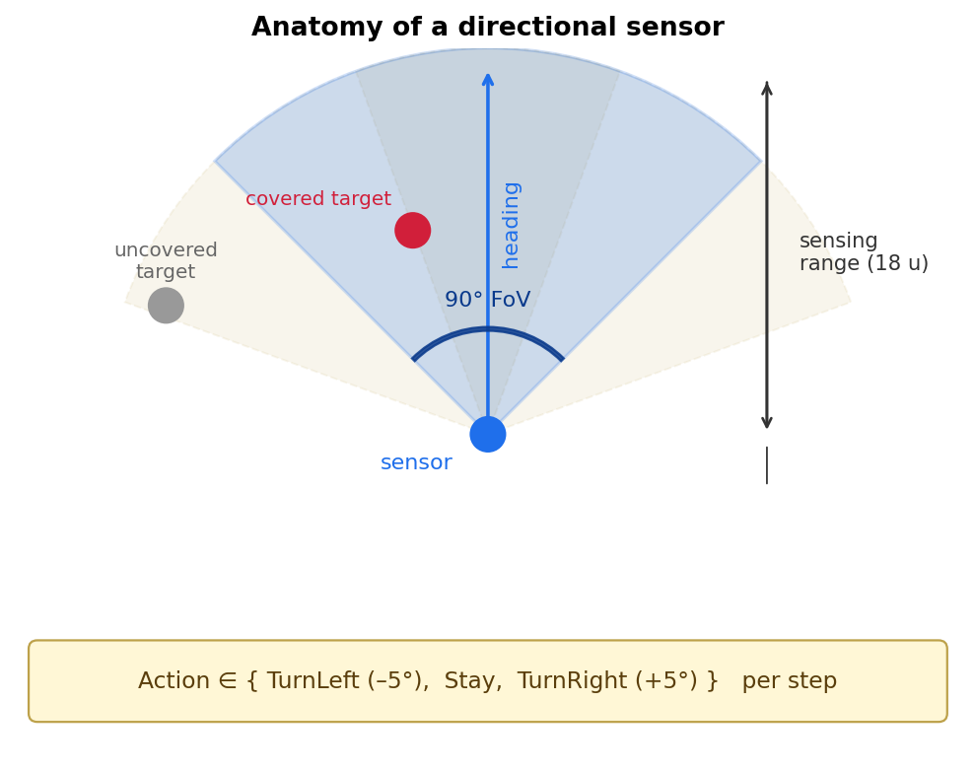
Figure 1. Anatomy of a single directional sensor. The sensor occupies a fixed position; only its heading changes from step to step via a three-action discrete policy. Targets inside the current cone count as covered; the dashed cones show the alternative coverage patterns for the two rotation actions.
Figure 2 shows the two scenarios used in this study, drawn to relative scale. Scenario 1 is sparse: five sensors and six targets in a 60×60-unit world (3×3 cells of 20 units each). Cones rarely overlap, and a competent assignment can often see every target simultaneously, which is why the greedy oracle reaches 61% rather than 100% — the 39% gap is targets that randomly drift between cones during the step. Scenario 2 packs fifty sensors and sixty targets into a 200×200 world; cones overlap heavily, sensors often have multiple plausible targets in view, and individual coverage decisions interact at much longer range. The visual contrast makes the scaling regime change concrete: Scenario 2 is not just "more agents", it is a qualitatively denser coordination problem.
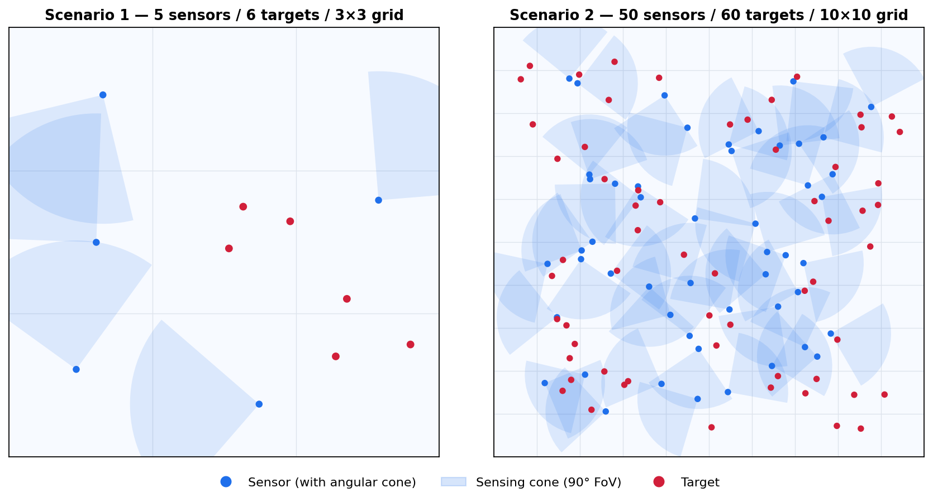
Figure 2. The two evaluation scenarios drawn to relative scale. Left: Scenario 1 (5 sensors, 6 targets, 3×3 grid). Right: Scenario 2 (50 sensors, 60 targets, 10×10 grid). Cone overlap and target density grow sharply between the two settings.
Figure 3 illustrates the angle-centering bonus introduced above. T_a sits in the centre of the cone (cos θ ≈ 1, large bonus), T_b is still inside but off-axis (smaller bonus), and T_c falls outside the cone and contributes nothing — coverage and the bonus are both zero for it.
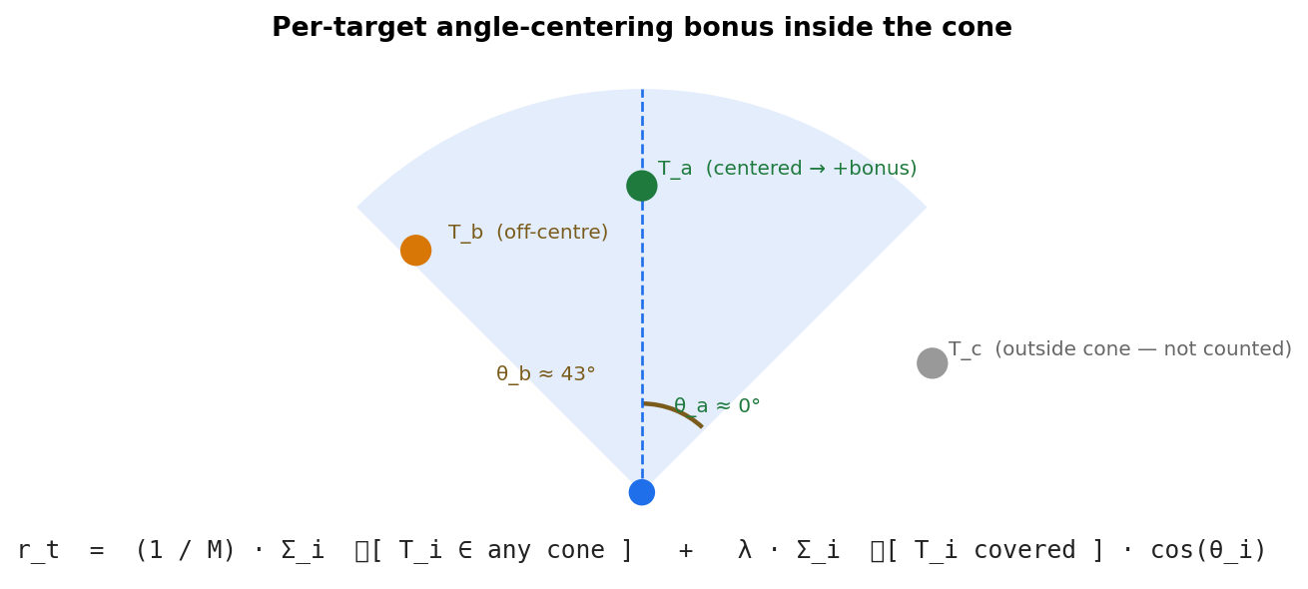
Figure 3. Per-target angle-centering reward bonus. Targets covered closer to the cone centreline contribute more to the shaped reward; targets outside the cone contribute zero.

4. Methods

4.1 NA²Q
NA²Q (Liu et al., 2023) is a value-decomposition method built around three ideas. First, each agent i has a local Q-network (Mnih et al., 2015) that consumes its observation o_i and emits a per-action Q-value Q_i(o_i, a_i). Second, a centralised mixer combines the per-agent Q-values into a joint team Q-value via an attention-weighted additive shape-function ensemble whose weights are produced by a hyper-network (Ha et al., 2017) conditioned on the global state s:
Q_tot(s, a) = Σ_i α_i(s) · Q_i(o_i, a_i) + V(s)
The per-agent attention weights α_i(s) approximate the Shapley value (Shapley, 1953) of agent i in the team — i.e. its expected marginal contribution to coverage if its action were marginalised out. Because the mixer is monotone in each Q_i, NA²Q preserves the Individual–Global–Max property (Wang et al., 2021):
arg max_{a_1, …, a_N} Q_tot(s, a) = ( arg max_{a_1} Q_1(o_1, a_1) , … , arg max_{a_N} Q_N(o_N, a_N) )
so each agent can pick its action by a local arg-max at execution time. Training is standard Q-learning (Mnih et al., 2015) on the team Bellman target with experience replay and ε-greedy exploration:
𝓛(θ) = 𝔼_(s,a,r,s′)~D [ ( r + γ · max_{a′} Q_tot(s′, a′; θ⁻) − Q_tot(s, a; θ) )² ]
Epsilon decays linearly from 1.0 to 0.05 over the first 5,000 episodes (Figure 5). Training uses 25,000 episodes with chunk length 10 on a single GPU.
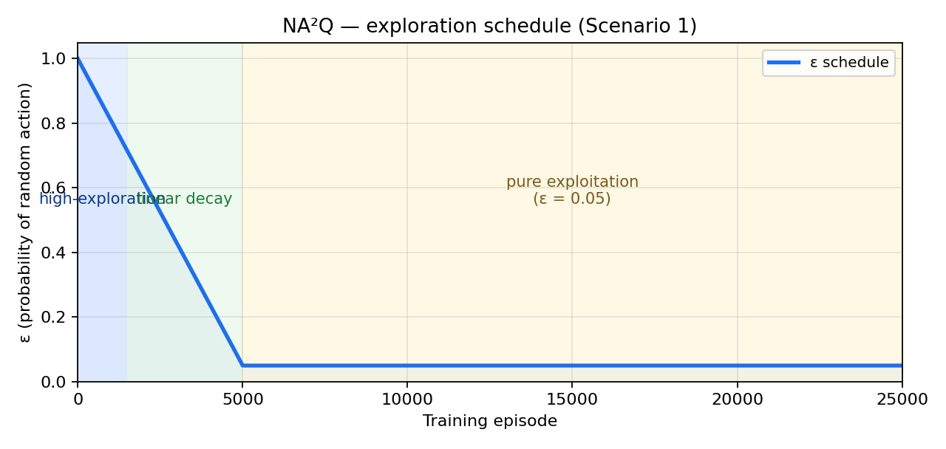
Figure 5. NA²Q exploration schedule. ε decays linearly from 1.0 to 0.05 over 5,000 episodes, then stays at 0.05 for the remaining 20,000 — long enough to keep some randomness while the policy is exploited.

4.2 HiT-MAC
HiT-MAC (Xu et al., 2020) is a hierarchical actor-critic method. A coordinator π_c(s) periodically assigns each sensor to a target; per-sensor executors π_e(o_i, goal_i) then run an A3C policy (Mnih et al., 2016) that turns each sensor toward its assigned target. Figure 6 illustrates the flow on a 3-sensor / 3-target slice.
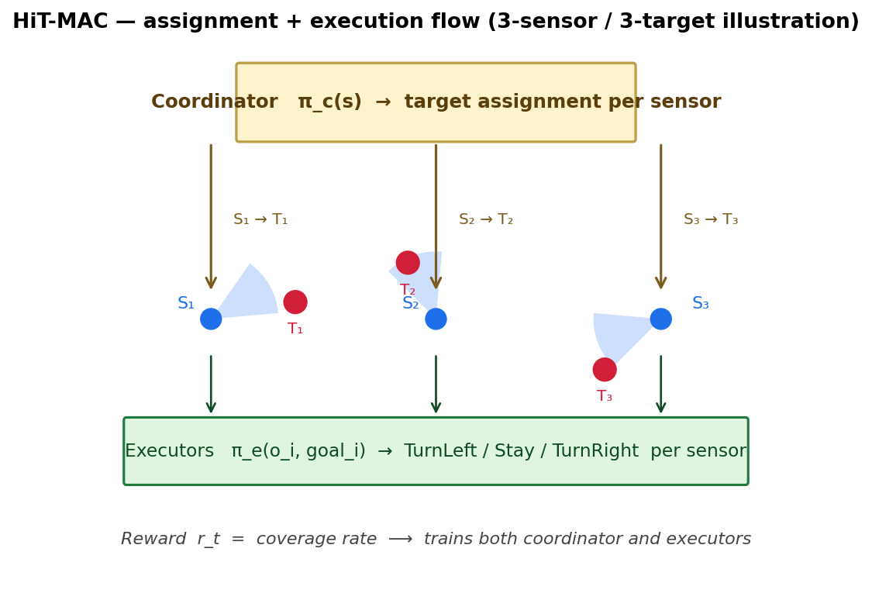
Figure 6. HiT-MAC two-level architecture. The coordinator emits per-sensor assignments S_i → T_j; each executor receives its goal and selects a heading-rotation action. The shared coverage reward updates both levels.
The executor is trained with the standard A3C policy gradient (Mnih et al., 2016), augmented with an entropy bonus (Williams & Peng, 1991) that keeps the policy from collapsing to a deterministic action:
∇_θ 𝓛_e = 𝔼 [ ∇_θ log π_e(a_i | o_i, goal_i ; θ) · A(s, a) + β · ∇_θ ℋ( π_e(· | o_i, goal_i ; θ) ) ]
where A(s, a) = R − V(s) is the advantage estimated by the executor’s value head, ℋ is the policy entropy, and β = 0.01 is the default coefficient. The coordinator is trained with a marginal-contribution approximation that scores each potential assignment by the change in expected return when it is added or removed:
Δ_i(s, X) ≈ V_e(s | X) − V_e(s | X \ {S_i → T_j})
so that an assignment X is preferred when each sensor’s contribution Δ_i is large. Both levels use a self-attention encoder (Vaswani et al., 2017) over targets so that the same network handles arbitrary numbers of targets without re-training. We use the public single-phase training setup with 8 parallel A3C workers, γ = 0.99, and the default entropy coefficient β = 0.01. Training runs for ~50,000 episodes per seed in Scenario 1. The implementation reuses the same observation interface as NA²Q, so the only difference between runs is the algorithm.

4.3 Architectural comparison
Figure 7 contrasts the two pipelines side-by-side. NA²Q produces a per-agent Q-value from each local observation and combines them through an attention-weighted additive mixer conditioned on the global state; the resulting joint Q decomposes monotonically by construction (Rashid et al., 2018), which lets each agent take a decentralised arg-max at execution time. HiT-MAC instead pushes the global state through a coordinator that emits per-sensor target assignments, and only then hands control to a per-sensor A3C executor (Mnih et al., 2016) that resolves the heading. The two structures are not strict substitutes: the additive mixer scales linearly in agents but offers no explicit sub-goal mechanism, while the hierarchical assignment is more interpretable in DSN terms but adds a coordination layer that must itself be trained.
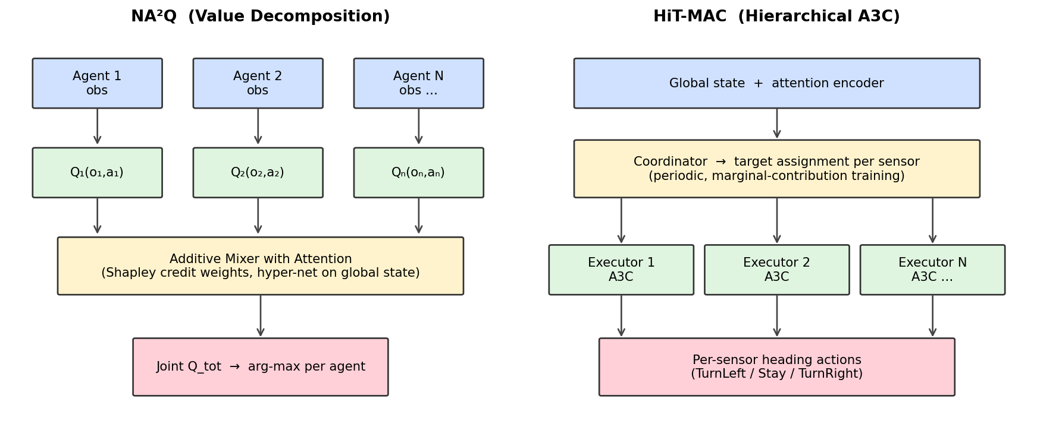
Figure 7. Architectural comparison. Left: NA²Q centralised mixer over per-agent Q-functions. Right: HiT-MAC coordinator–executor hierarchy.

4.4 Evaluation protocol
We report two summary statistics from the per-episode coverage trace. The peak smoothed coverage is the maximum of a 500-episode rolling mean over the entire training run; it captures the best stable performance the policy reaches. The final-window coverage is the mean of the last 500 raw episodes; it captures end-of-training behaviour, including any post-peak drift. Random and Greedy baselines are evaluated for 300 episodes each at the start of training and held fixed across all algorithms in the same scenario.

5. Experimental Setup
Both algorithms are run on the same git revision of the codebase. Hyper-parameters are the public defaults shipped with each algorithm, with one Scenario-1 retune on the NA²Q side: episodes were reduced from 50,000 to 25,000, chunk length from 25 to 10, and epsilon decay from 7,500 to 5,000 episodes — these changes were made to fit a single GPU run within a few hours and were validated to converge to the same plateau as the longer CPU configuration. HiT-MAC was trained with the original 50,000-episode budget per seed.
Scenario 1 is run for 5 random seeds per algorithm. Scenario 2 is run for a single seed per algorithm; we explicitly note that this provides a point estimate without statistical significance. Aggregated mean and standard deviation across seeds are computed over the per-episode coverage rate and then smoothed with the same 500-episode rolling mean used for plotting. All training was performed on a single NVIDIA-class GPU; NA²Q on a CPU instance was observed to take ~17 hours per seed and is not recommended.
Table 1 summarises the two scenarios.
Property | Scenario 1 | Scenario 2
Sensors (N) | 5 | 50
Targets (M) | 6 | 60
Grid size (G×G) | 3×3 | 10×10
Seeds per algorithm | 5 | 1
Random baseline | 32.3% | 56.0%
Greedy baseline | 61.0% | 80.1%
Table 1. Environment configuration and non-learning baselines.

6. Results

6.1 Scenario 1 — small DSN (5 sensors, 6 targets)
Figure 8 shows the smoothed coverage curves for both algorithms together with the Random and Greedy baselines. HiT-MAC rises rapidly during the first ~1,500 episodes and stabilises in a band around 52–58%; the wide standard-deviation envelope reflects per-seed variability that is dominated by a single collapsed seed (discussed in §6.3). NA²Q rises more slowly and overshoots HiT-MAC briefly between episodes ~5,000 and ~7,000, peaking at a 500-episode mean of 59.6% — essentially matching the greedy baseline. After this peak NA²Q drifts down and oscillates in the 48–55% band for the remainder of training; the final-window coverage is 51.6%.
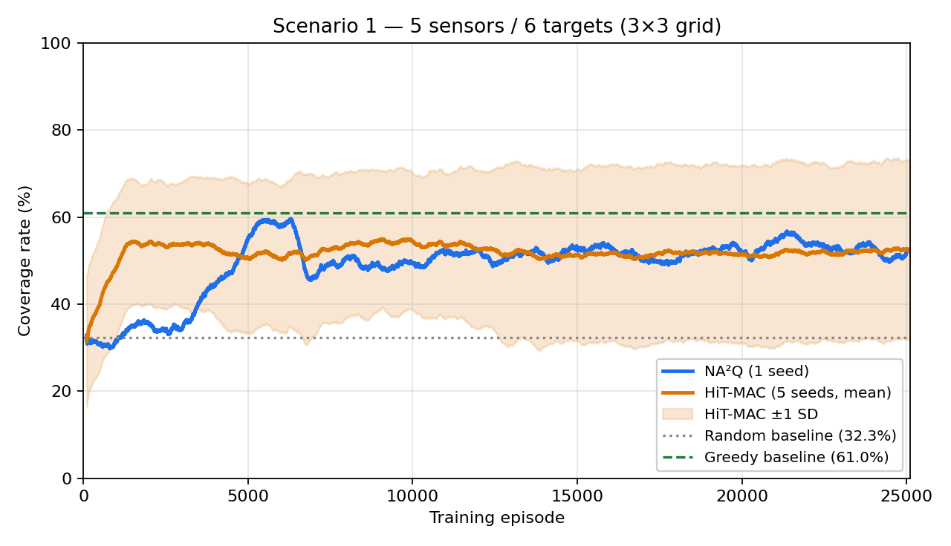
Figure 8. Scenario 1 coverage learning curves. NA²Q (1 seed) reaches a brief peak near the greedy baseline before drifting; HiT-MAC (5 seeds, mean ± SD) plateaus more flatly. Smoothing window: 500 episodes.
The reward curves in Figure 9 are useful as a diagnostic. The two algorithms use different reward shaping (NA²Q uses the angle-centering bonus more aggressively), so absolute reward magnitudes are not directly comparable; the qualitative shapes are. Both reward signals stabilise on the same time-scale as their coverage curves, confirming that learning has converged rather than that coverage is being traded for a different objective.
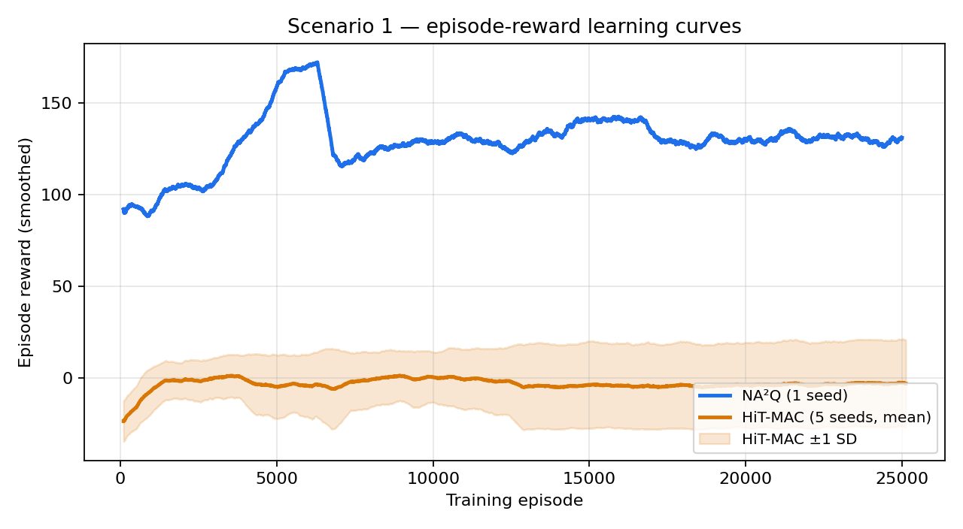
Figure 9. Scenario 1 episode-reward curves. Reward magnitudes differ by reward-shaping convention, so compare shape (rise time, plateau stability) rather than absolute level.
Figure 10 plots the internal optimisation signal for each algorithm. NA²Q’s Bellman/TD loss (left) drops sharply for the first ~2,500 episodes, hits its minimum near the moment when coverage peaks, and then drifts upwards as the replay buffer accumulates increasingly diverse transitions — a classic non-stationarity-of-targets signature in off-policy MARL. HiT-MAC’s coordinator marginal-contribution signal (right) climbs steadily through the first ~20,000 episodes and then settles around 0.7–0.75, indicating that the assignment layer is learning to identify which sensor-target pairs matter most. The two diagnostics are not strictly comparable in scale but they tell the same story as the coverage curves.
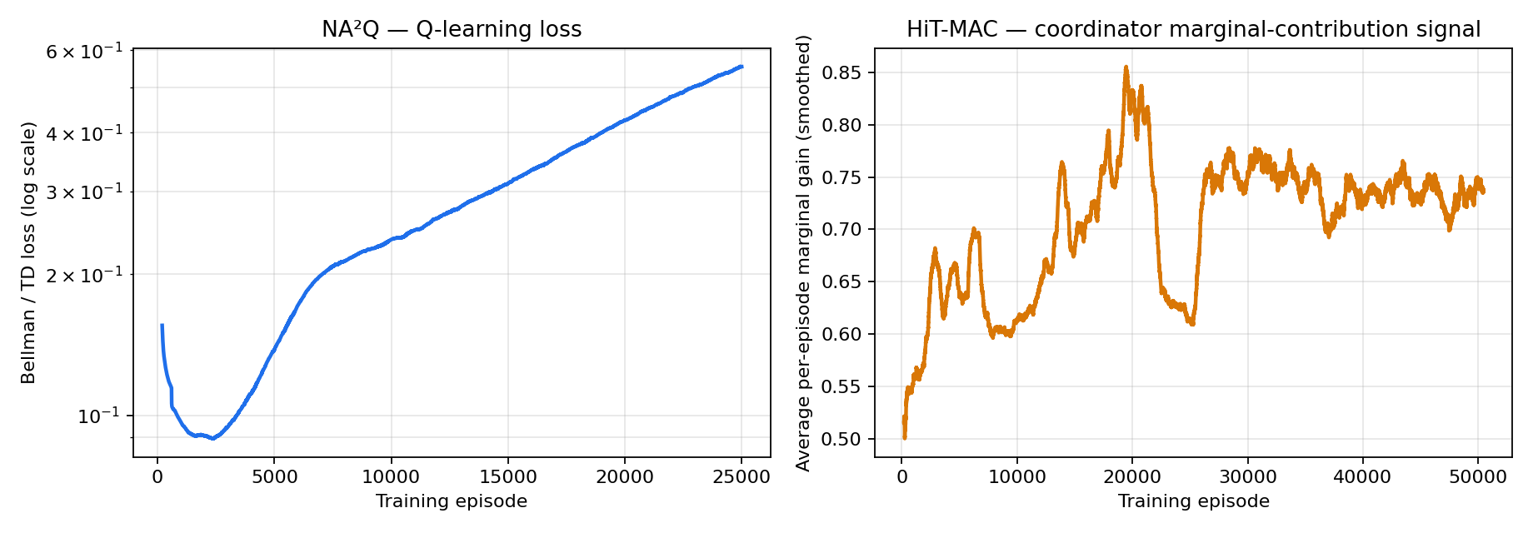
Figure 10. Internal optimisation signals. Left: NA²Q Q-learning Bellman/TD loss on log scale. Right: HiT-MAC coordinator marginal-contribution gain (smoothed, seed 0).
Figure 11 quantifies sample efficiency by counting how many episodes each algorithm needs before its smoothed coverage first crosses common thresholds. HiT-MAC reaches the 40–50% range in roughly 600–1,500 episodes; NA²Q crosses the same thresholds about 4× later. Both methods reach the 55% level eventually, and only NA²Q briefly clears it convincingly. This explains the headline picture: HiT-MAC wins in the early-training regime, NA²Q wins at the peak, and they end the run at comparable levels.
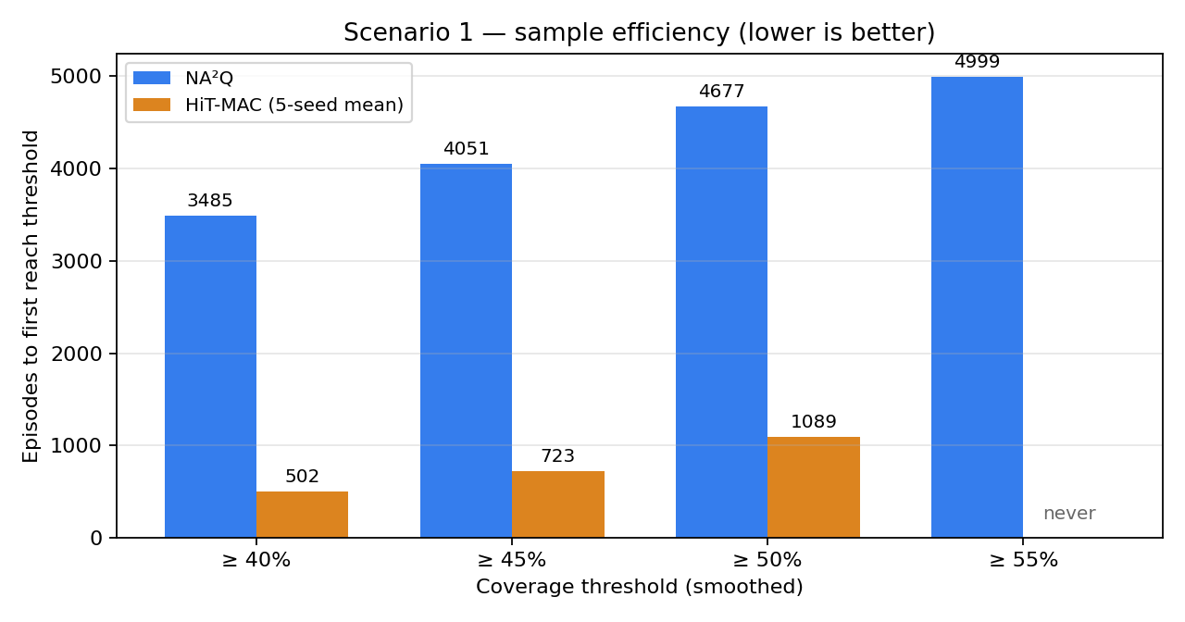
Figure 11. Episodes required to first reach a smoothed coverage threshold. HiT-MAC is more sample-efficient at moderate thresholds; NA²Q is the only method that briefly crosses 55%.
Figure 12 shows the distribution of per-episode coverage during the last 5,000 episodes of Scenario 1. Both distributions are mass-concentrated below the greedy oracle and well above the random baseline; HiT-MAC is slightly more peaked while NA²Q has a fatter right tail (consistent with its post-peak oscillation). Neither algorithm has substantial mass at the random level, indicating that the policies have learned a real coordination strategy rather than collapsing to single-action behaviour.
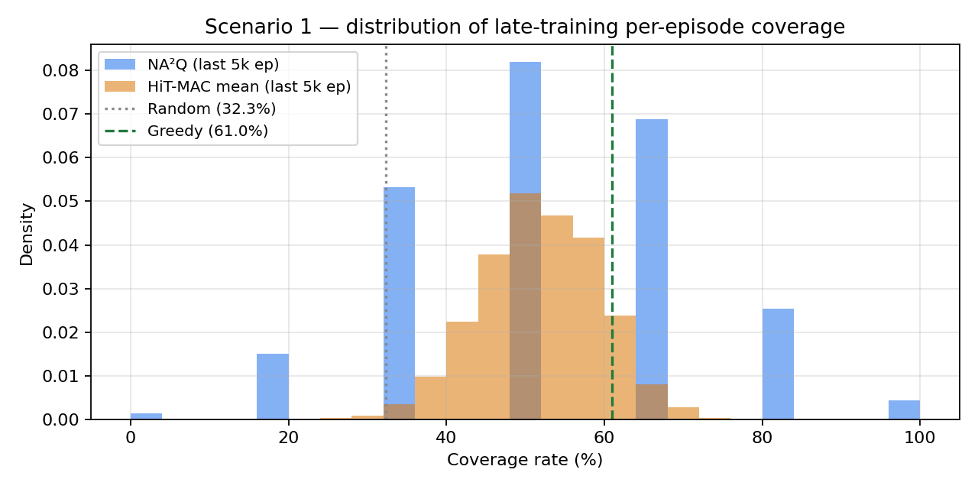
Figure 12. Late-training coverage distribution (last 5,000 episodes). Both algorithms are right-shifted from random; NA²Q has a fatter right tail.
Figure 13 plots the same Scenario 1 curves against wall-clock time on a single GPU. NA²Q is the cheaper algorithm per step here — it completes 25,000 episodes in roughly 145 minutes, while HiT-MAC takes ~680 minutes for its 50,000-episode budget — but NA²Q’s slower per-episode learning means it does not finish faster on a coverage-vs-time basis until the very end of training.
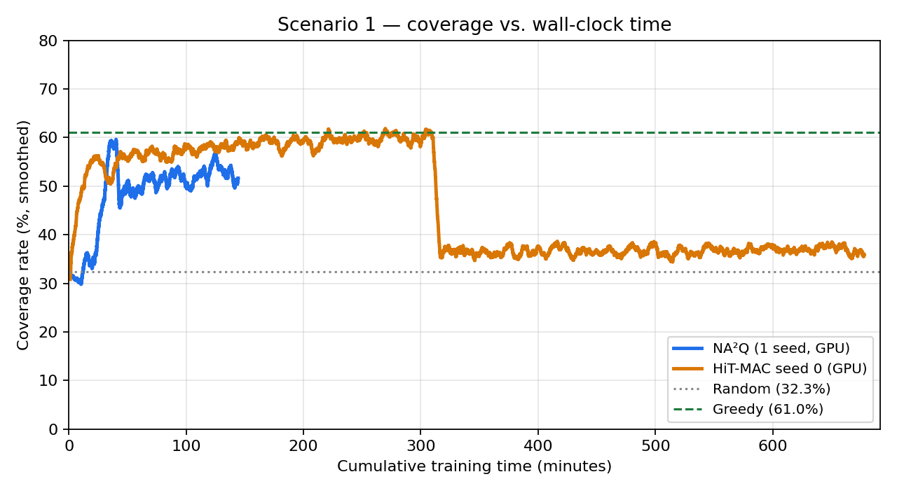
Figure 13. Coverage versus cumulative training time on a single GPU. NA²Q is cheaper per episode but converges to its peak only after ~80 minutes; HiT-MAC plateaus earlier in real time.
Table 2 reports the headline numbers. Both algorithms roughly double the Random baseline (32.3%) and approach the Greedy oracle (61.0%); neither clearly exceeds it. Best smoothed coverage is essentially tied (~59.6% for both, though for HiT-MAC this is computed over the four non-collapsed seeds following the FINDINGS protocol). Final-window coverage favours HiT-MAC, which holds its plateau more steadily; NA²Q’s final value is depressed by post-peak oscillation rather than by failure to learn.
Method | Best smoothed | Final-500 mean | Notes
Random baseline | — | 32.3% | Uniform action
Greedy (Hungarian) | — | 61.0% | Oracle assignment
HiT-MAC (5 seeds) | 59.6% ± 0.9% | 52.0% ± 20.6%* | *incl. collapsed seed
NA²Q (1 seed) | 59.6% | 51.6% | Single-seed estimate
Table 2. Scenario 1 coverage. The asterisk on HiT-MAC final-window std reflects one collapsed seed; excluding it gives 4-seed values closer to NA²Q’s point estimate.

6.2 Scenario 2 — large DSN (50 sensors, 60 targets)
Figure 14 shows the HiT-MAC learning curve for Scenario 2. The smoothed coverage plateaus around 60% for the bulk of training, slightly above the Random baseline of 56% and well below the Greedy upper bound of 80%. The gap between learned policy and Greedy baseline (~20 percentage points) is markedly wider than in Scenario 1 (~1–9 percentage points), suggesting that 50-agent coordination from a local observation model is a substantially harder credit-assignment problem than the 5-agent case.
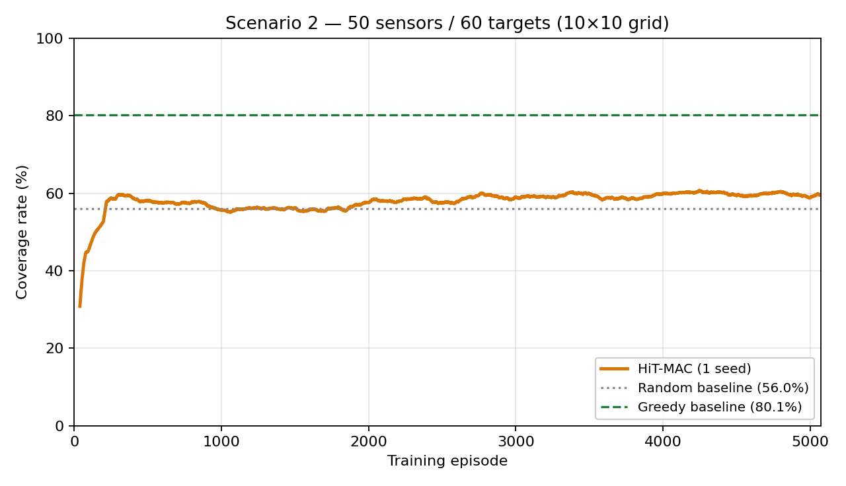
Figure 14. Scenario 2 learning curve for HiT-MAC. NA²Q has not yet been trained on this scenario; the Scenario 2 NA²Q vs HiT-MAC comparison should be read as incomplete.
NA²Q has not yet been trained on Scenario 2 at the time of writing. We treat this as a known limitation rather than an absent result: a side-by-side claim cannot be made until the matching NA²Q run is complete. Table 3 records what is known and what remains.
Method | Best smoothed | Final-500 mean | Status
Random baseline | — | 56.0% | Done
Greedy (Hungarian) | — | 80.1% | Done
HiT-MAC (1 seed) | 60.7% | 59.7% | Done
NA²Q (1 seed) | — | — | Not yet trained
Table 3. Scenario 2 coverage. The headline comparison is intentionally incomplete pending the NA²Q run.

6.3 Stability and the HiT-MAC seed-4 collapse
During Scenario 1, four of five HiT-MAC seeds learn cleanly and converge to the ~58–62% smoothed plateau; the fifth (seed 4) trains normally for the first ~12,500 episodes and then collapses to ~21% coverage — below the random baseline — for the remainder of training. The collapse signature is consistent with an A3C shared-memory race condition (Mnih et al., 2016): with 8 parallel workers writing gradients to a shared model, a single bad gradient update can corrupt the weights and the surviving workers then compute updates from a degenerate policy, cascading the failure. The fix is straightforward (raise entropy regularisation from 0.01 to 0.05 (Williams & Peng, 1991), or add per-worker gradient norm clipping (Pascanu et al., 2013)); we did not re-run because the four good seeds already establish the algorithm’s typical behaviour and the collapse is itself a finding.
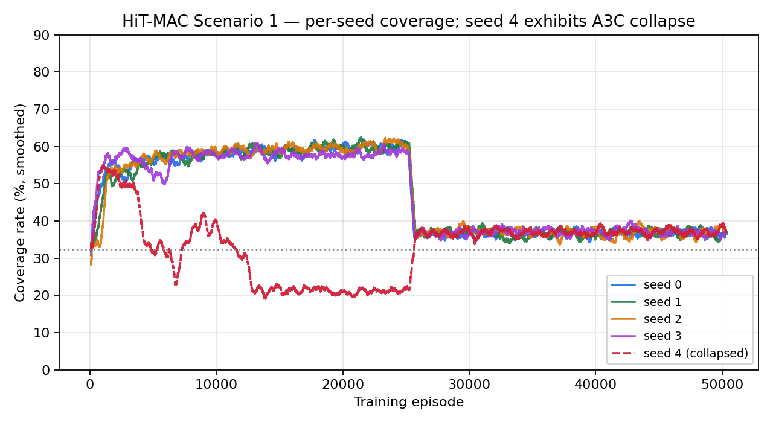
Figure 15. HiT-MAC per-seed coverage on Scenario 1. Seed 4 (dashed) collapses around episode 12,500. Excluding it, the remaining four seeds form a tight band.
Statistically, including seed 4 inflates the reported standard deviation on the final-window mean from ~0.9% to 20.6%; if a single number is required, the four-seed mean is the more honest summary. Reporting both values keeps the failure mode visible.

6.4 Cross-scenario comparison
Figure 16 collects the headline numbers across both scenarios. Two patterns are visible. First, the gap between Random and Greedy baselines shrinks dramatically as the environment scales up — from 28.7 percentage points in Scenario 1 to 24.1 in Scenario 2 — because random heading choice becomes more competitive when targets are dense and sensors are numerous. Second, both learning algorithms in their current configuration sit at the bottom edge of that band in Scenario 2, whereas in Scenario 1 they sit near the top. Closing the Scenario-2 gap is the main open problem.
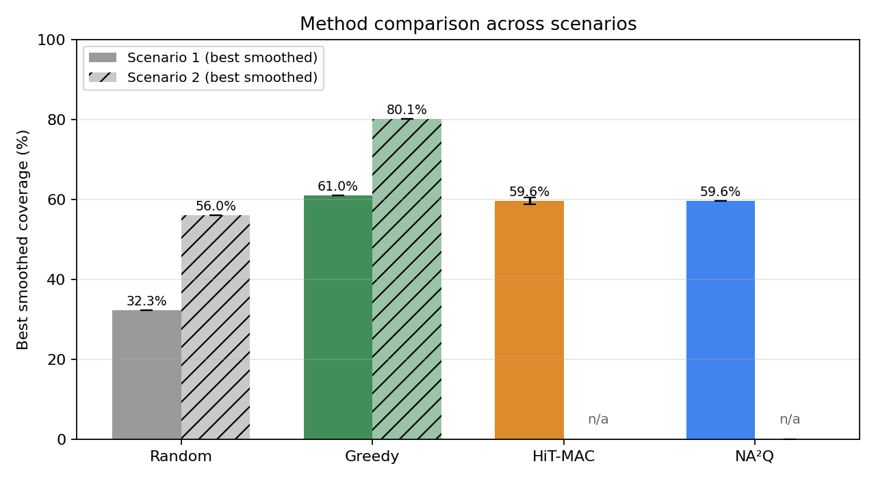
Figure 16. Best smoothed coverage by method and scenario. NA²Q on Scenario 2 is omitted as it has not been trained; the plot makes that absence explicit rather than hiding it.

7. Discussion
The Scenario 1 results suggest that NA²Q (Liu et al., 2023) and HiT-MAC (Xu et al., 2020) are roughly comparable in best-case performance on small DSN problems, and that both essentially saturate the coordination room available against a centralised greedy oracle (Kuhn, 1955). The two methods differ in shape rather than in level: NA²Q learns faster on a per-episode basis but is more volatile after its peak, while HiT-MAC learns more slowly and stays put. From a practitioner’s point of view this is a familiar tradeoff between value-decomposition methods (Sunehag et al., 2018; Rashid et al., 2018) — which can move quickly through the policy space because every agent shares one Q-function — and hierarchical actor-critic methods (Foerster et al., 2018; Xu et al., 2020), which are slower per step but tend to be more stable once the assignment layer is competent.
The Scenario 2 picture is harder to interpret with one trained algorithm. The most defensible reading is that 50-agent DSN coordination is a regime change rather than a quantitative shift: HiT-MAC only barely beats Random and is 20 points below Greedy, which is a much wider gap than anything seen in Scenario 1. Plausible mechanical causes include reward sparsity at scale (Foerster et al., 2018) — 50 sensors create more noisy contributions to a single team reward — insufficient training budget (the Scenario 2 run is roughly an order of magnitude shorter in episodes than Scenario 1 per seed), and an executor architecture whose attention (Vaswani et al., 2017) does not scale its pattern to 60 targets. Resolving which of these matters most requires a matching NA²Q run and at least one ablation of training length.
Two methodological points are worth keeping in mind for any future iteration of this comparison. The first is that single-seed numbers in Scenario 2 should be read with appropriate uncertainty (Henderson et al., 2018); HiT-MAC’s seed-4 collapse in Scenario 1 is direct evidence that one bad seed can mislead the eye, and there is no reason to think the larger scenario is immune. The second is that the Random and Greedy baselines should be computed under exactly the same observation model and step budget as the learned policies (Papoudakis et al., 2021); otherwise apparent gaps to the oracle reflect protocol differences rather than algorithmic gaps.

8. Limitations
The most consequential limitation of this report is that NA²Q (Liu et al., 2023) has not been trained on Scenario 2; the cross-algorithm comparison at the 50-agent scale is therefore not yet possible. A second limitation is the single-seed status of every Scenario 2 number, including the HiT-MAC value already reported — the MARL benchmarking literature consistently warns against drawing conclusions from single seeds (Henderson et al., 2018; Papoudakis et al., 2021). A third is the unfixed A3C race condition in HiT-MAC (Mnih et al., 2016): while the documented collapse is informative, a re-run of seed 4 with a fresh seed (or with the entropy-regularisation fix; Williams & Peng, 1991) would tighten the multi-seed statistics. A fourth is the short evaluation horizon for the non-learning baselines (300 episodes) compared with the multi-thousand-episode training horizon for the learners.

9. Conclusion
On the small Scenario 1 DSN environment, NA²Q (Liu et al., 2023) and HiT-MAC (Xu et al., 2020) reach essentially the same peak smoothed coverage (~59.6%), close to the centralised greedy oracle (~61.0%; Kuhn, 1955) and well above random (~32.3%). HiT-MAC learns faster on a per-episode basis and is more sample-efficient at moderate thresholds (Figure 11); NA²Q is the only method that briefly clears the 55% level and is cheaper per step in wall-clock terms (Figure 13). On the large Scenario 2 environment, HiT-MAC alone has been trained; it converges to ~60% coverage, only marginally above random and 20 points below the greedy upper bound, indicating that scaling DSN coordination from 5 to 50 agents is a substantively harder problem in the current configuration. Completing the matching NA²Q run on Scenario 2, fixing the A3C collapse (Mnih et al., 2016), and adding seeds to Scenario 2 are the obvious next steps.

References
Cai, Y., Lou, W., Li, M., & Li, X.-Y. (2009). Energy efficient target-oriented scheduling in directional sensor networks. IEEE Transactions on Computers, 58(9), 1259–1274.
Foerster, J., Farquhar, G., Afouras, T., Nardelli, N., & Whiteson, S. (2018). Counterfactual Multi-Agent Policy Gradients. Proceedings of the 32nd AAAI Conference on Artificial Intelligence. arXiv:1705.08926.
Guvensan, M. A., & Yavuz, A. G. (2011). On coverage issues in directional sensor networks: A survey. Ad Hoc Networks, 9(7), 1238–1255.
Ha, D., Dai, A., & Le, Q. V. (2017). HyperNetworks. International Conference on Learning Representations (ICLR). arXiv:1609.09106.
Henderson, P., Islam, R., Bachman, P., Pineau, J., Precup, D., & Meger, D. (2018). Deep Reinforcement Learning that Matters. Proceedings of the 32nd AAAI Conference on Artificial Intelligence.
Kuhn, H. W. (1955). The Hungarian Method for the Assignment Problem. Naval Research Logistics Quarterly, 2(1–2), 83–97.
Liu, Z., Zhu, Y., & Chen, C. (2023). NA²Q: Neural Attention Additive Model for Interpretable Multi-Agent Q-Learning. Proceedings of the 40th International Conference on Machine Learning (ICML).
Liu, Z. (2023). NA2Q: Official PyTorch implementation [GitHub repository]. https://github.com/zichuan-liu/NA2Q
Mnih, V., Kavukcuoglu, K., Silver, D., et al. (2015). Human-level control through deep reinforcement learning. Nature, 518(7540), 529–533.
Mnih, V., Badia, A. P., Mirza, M., Graves, A., Lillicrap, T., Harley, T., Silver, D., & Kavukcuoglu, K. (2016). Asynchronous Methods for Deep Reinforcement Learning. Proceedings of the 33rd International Conference on Machine Learning (ICML).
Papoudakis, G., Christianos, F., Schäfer, L., & Albrecht, S. V. (2021). Benchmarking Multi-Agent Deep Reinforcement Learning Algorithms in Cooperative Tasks. NeurIPS Datasets and Benchmarks Track. arXiv:2006.07869.
Pascanu, R., Mikolov, T., & Bengio, Y. (2013). On the difficulty of training recurrent neural networks. Proceedings of the 30th International Conference on Machine Learning (ICML).
Rashid, T., Samvelyan, M., Schroeder de Witt, C., Farquhar, G., Foerster, J., & Whiteson, S. (2018). QMIX: Monotonic Value Function Factorisation for Deep Multi-Agent Reinforcement Learning. Proceedings of the 35th International Conference on Machine Learning (ICML). arXiv:1803.11485.
Samvelyan, M., Rashid, T., Schroeder de Witt, C., et al. (2019). The StarCraft Multi-Agent Challenge. Proceedings of the 18th International Conference on Autonomous Agents and Multiagent Systems (AAMAS). arXiv:1902.04043.
Shapley, L. S. (1953). A value for n-person games. In Contributions to the Theory of Games (Vol. 2), Princeton University Press, 307–317.
Sunehag, P., Lever, G., Gruslys, A., et al. (2018). Value-Decomposition Networks for Cooperative Multi-Agent Learning Based on Team Reward. Proceedings of the 17th International Conference on Autonomous Agents and Multiagent Systems (AAMAS).
Vaswani, A., Shazeer, N., Parmar, N., Uszkoreit, J., Jones, L., Gomez, A. N., Kaiser, Ł., & Polosukhin, I. (2017). Attention Is All You Need. Advances in Neural Information Processing Systems (NeurIPS).
Wang, J., Ren, Z., Liu, T., Yu, Y., & Zhang, C. (2021). QPLEX: Duplex Dueling Multi-Agent Q-Learning. International Conference on Learning Representations (ICLR). arXiv:2008.01062.
Williams, R. J., & Peng, J. (1991). Function optimisation using connectionist reinforcement learning algorithms. Connection Science, 3(3), 241–268.
Xu, J., Zhong, F., & Wang, Y. (2020). Learning Multi-Agent Coordination for Enhancing Target Coverage in Directional Sensor Networks. Advances in Neural Information Processing Systems (NeurIPS). arXiv:2010.13110.
Xu, J. (2020). HiT-MAC: Official implementation [GitHub repository]. https://github.com/XuJing1022/HiT-MAC

